Setup Visual studio Code

Install Visual Studio Code\*\*: Download and install Visual Studio Code from the official website (https://code.visualstudio.com/) for your operating system. Follow the installation instructions specific to your platform.

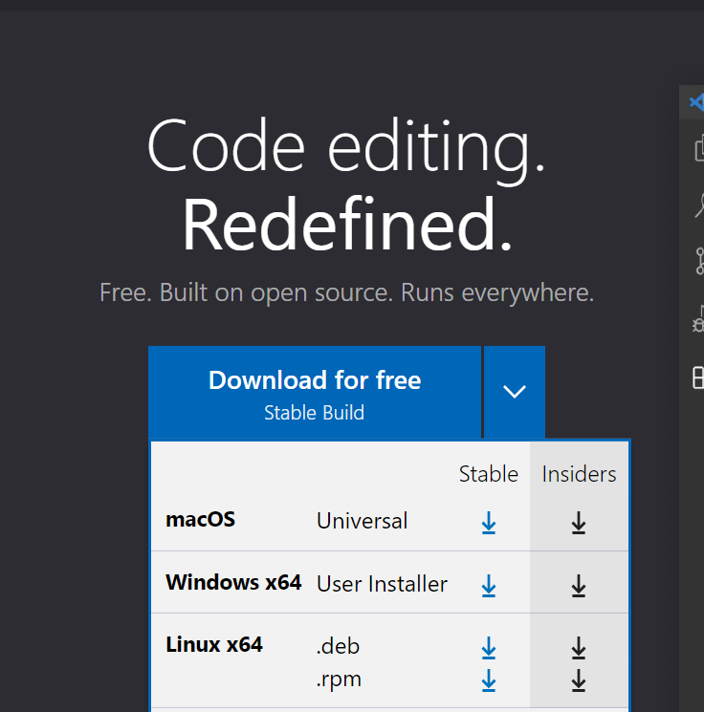

Install extension

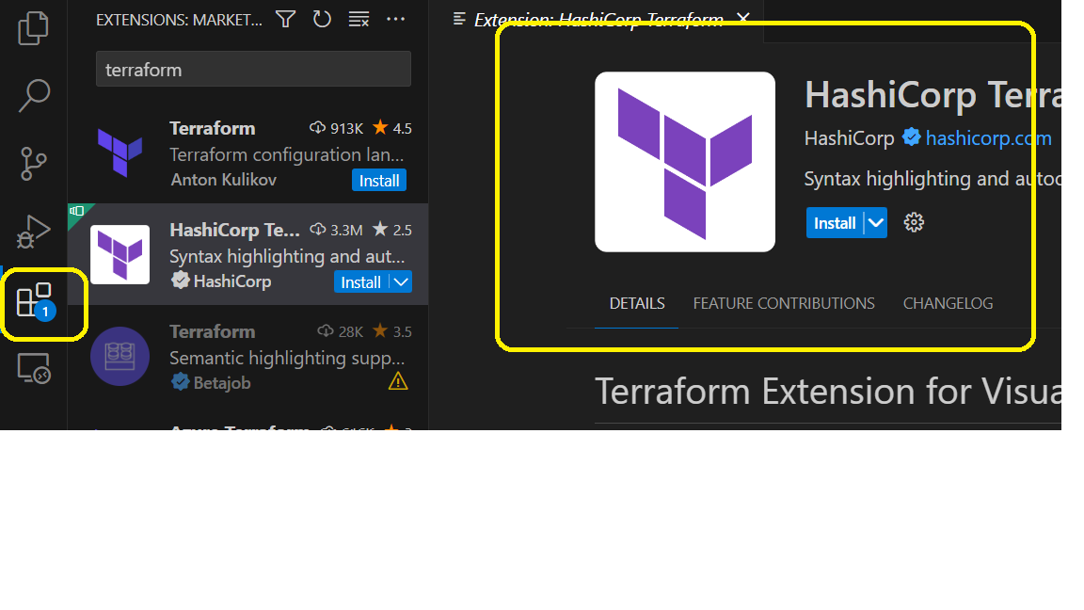

Create a Folder on your system